**index.html**

<!DOCTYPE html>

<html>

<head>

<title>The big sale website</title>

</head>

<body>

<h1>Welcome to the big sale website</h1>

<hr/>

<p>

<a href="page2.html">Click here to access our secret sale</a>

</p>

</body>

</html>

**page2.html**

<!DOCTYPE html>

<html>

<head>

<title>The big sale website</title>

</head>

<body>

<h1>The big sale - only on till Friday!</h1>

<hr/>

<img src="img/sale.png" alt="sale"/><img src="img/buynow.jpg" alt="buy now"/>

<p>Enter your <b>secret sale code</b></p>

<form action="/check.php" method="GET">

<input type="text" name="code"/>

<input type="submit">

</form>

</p>

</body>

</html>

**index.html**

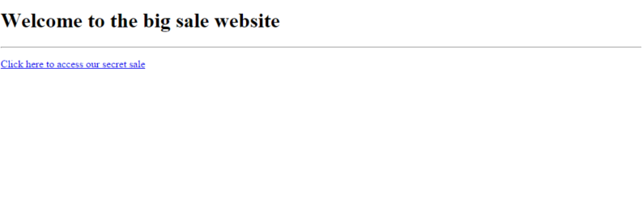

**page2.html**

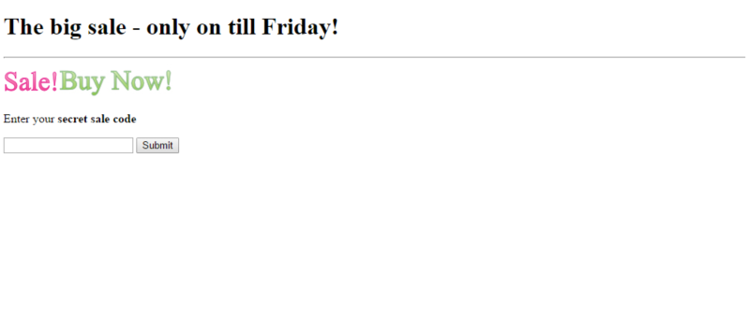

Img/buynow.jpg

Img/sale.png

**check.php**

<html>

<head>

<title>Sale code access!</title>

</head>

<body>

<?php

if($_GET['code']=="MAGICDUCKS") {

?>

Yay! Let's go shopping!

<a href="sale.php">Click here to go the secret sale</a>

<?php

} else {

?>

You didn't have the code. Better luck next year!

<?php

}

?>

</body>

</html>

|  |
| --- |
| **Choose the correct output for check.php** |
| <html>  <head>  <title>Sale code access!</title>  </head>  <body>  Yay! Let's go shopping!  <a href="sale.php">Click here to go the secret sale</a>  </body>  </html> |
|  |
| **Choose the correct output for check.php** |
| <html>  <head>  <title>Sale code access!</title>  </head>  <body>  You didn't have the code. Better luck next year!  </body>  </html> |

**check.php**

<html>

<head>

<title>Sale code access!</title>

</head>

<body>

<?php

**IF the code sent via the GET request = “MAGICDUCKS” THEN**

?>

Yay! Let's go shopping!

<a href="sale.php">Click here to go the secret sale</a>

<?php

**ELSE**

?>

You didn't have the code. Better luck next year!

<?php

**END IF**

?>

</body>

</html>

|  |
| --- |
| **Choose the correct output for check.php** |
|  |
|  |
| **Choose the correct output for check.php** |
|  |

**sale.php**

<html>

<head>

<title>Secret Sale</title>

</head>

<body>

<h1>Sale page</h1>

<hr>

<p>Click on any item to view the full details</p>

<?php

$db = mysql_connect("localhost","compsci_myuser","compsci_mypassword") or die("Error ".mysql_error($db));

mysql_select_db("compsci_examples");

$sql = "SELECT * FROM products ORDER BY id";

$result = mysql_query($sql) or die("Error ".mysql_error($db));

while($row = mysql_fetch_assoc($result)) {

?>

<div style='display: table-row;'>

<span style='display: table-cell; border: 1px solid #CCC;'>

<?php echo $row['name']; ?>

</span>

<span style='display: table-cell; border: 1px solid #CCC;'>

&pound;<?php echo $row['price']; ?>

</span>

<span style='display: table-cell; border: 1px solid #CCC;'>

<a href='item.php?id=<?php echo $row['id']?>'>Click for more information</a>

</span>

</div>

<?

}

?>

</body>

</html>

**sale.php**

<html>

<head>

<title>Secret Sale</title>

</head>

<body>

<h1>Sale page</h1>

<hr>

<p>Click on any item to view the full details</p>

<?php

**Connect to dbms or quit displaying an error message**

**Select compsci_examples database**

**Query database with SQL “SELECT * FROM products ORDER BY id”**

**While there is still another row in results**

<div style='display: table-row;'>

<span style='display: table-cell; border: 1px solid #CCC;'>

<?php **write name from $row**?>

</span>

<span style='display: table-cell; border: 1px solid #CCC;'>

&pound;<?php **write price from $row**?>

</span>

<span style='display: table-cell; border: 1px solid #CCC;'>

<a href='item.php?id=<?php **write id from $row**?>'>Click for more information</a>

</span>

</div>

**Loop**

</body>

</html>

|  |
| --- |
| **Choose the correct output for sale.php** |
| <html>  <head>  <title>Secret Sale</title>  </head>  <body>  <h1>Sale page</h1>  <hr>  <p>Click on any item to view the full details</p>  <div style='display: table-row;'>  <span style='display: table-cell; border: 1px solid #CCC;'>  Rocking Horse </span>  <span style='display: table-cell; border: 1px solid #CCC;'>  &pound;40.00 </span>  <span style='display: table-cell; border: 1px solid #CCC;'>  <a href='item.php?id=1'>Click for more information</a>  </span>  </div>  <div style='display: table-row;'>  <span style='display: table-cell; border: 1px solid #CCC;'>  Super splash gun </span>  <span style='display: table-cell; border: 1px solid #CCC;'>  &pound;11.00 </span>  <span style='display: table-cell; border: 1px solid #CCC;'>  <a href='item.php?id=2'>Click for more information</a>  </span>  </div>  <div style='display: table-row;'>  <span style='display: table-cell; border: 1px solid #CCC;'>  Loom bands </span>  <span style='display: table-cell; border: 1px solid #CCC;'>  &pound;5.50 </span>  <span style='display: table-cell; border: 1px solid #CCC;'>  <a href='item.php?id=3'>Click for more information</a>  </span>  </div>  <div style='display: table-row;'>  <span style='display: table-cell; border: 1px solid #CCC;'>  Skateboard </span>  <span style='display: table-cell; border: 1px solid #CCC;'>  &pound;9.00 </span>  <span style='display: table-cell; border: 1px solid #CCC;'>  <a href='item.php?id=4'>Click for more information</a>  </span>  </div>  </body>  </html> |

|  |
| --- |
| **Choose the correct output for sale.php** |
|  |

|  |
| --- |
| **Choose the correct output for sale.php** |
| <html>  <head>  <title>Secret Sale</title>  </head>  <body>  <h1>Sale page</h1>  <hr>  <p>Click on any item to view the full details</p>  <div style='display: table-row;'>  <span style='display: table-cell; border: 1px solid #CCC;'>  Rocking Horse </span>  <span style='display: table-cell; border: 1px solid #CCC;'>  &pound;40.00 </span>  <span style='display: table-cell; border: 1px solid #CCC;'>  <a href='item.php?id=1'>Click for more information</a>  </span>  </div>  </body>  </html> |

|  |
| --- |
| **Choose the correct output for sale.php** |
| <html>  <head>  <title>Secret Sale</title>  </head>  <body>  <h1>Sale page</h1>  <hr>  <p>Click on any item to view the full details</p>  <div style='display: table-row;'>  <span style='display: table-cell; border: 1px solid #CCC;'>  Rocking Horse </span>  <span style='display: table-cell; border: 1px solid #CCC;'>  &pound;40.00 </span>  <span style='display: table-cell; border: 1px solid #CCC;'>  <a href='item.php?id=1'>Click for more information</a>  </span>  </div>  <div style='display: table-row;'>  <span style='display: table-cell; border: 1px solid #CCC;'>  Loom bands </span>  <span style='display: table-cell; border: 1px solid #CCC;'>  &pound;5.50 </span>  <span style='display: table-cell; border: 1px solid #CCC;'>  <a href='item.php?id=3'>Click for more information</a>  </span>  </div>  </body>  </html> |

|  |
| --- |
| **Choose the correct output for sale.php** |
|  |

|  |
| --- |
| **Choose the correct output for sale.php** |
|  |

|  |
| --- |
| **Choose the correct output for sale.php** |
| <html>  <head>  <title>Secret Sale</title>  </head>  <body>  <h1>Sale page</h1>  <hr>  <p>Click on any item to view the full details</p>  <div style='display: table-row;'>  <span style='display: table-cell; border: 1px solid #CCC;'>  Loom bands </span>  <span style='display: table-cell; border: 1px solid #CCC;'>  &pound;5.50 </span>  <span style='display: table-cell; border: 1px solid #CCC;'>  <a href='item.php?id=3'>Click for more information</a>  </span>  </div>  <div style='display: table-row;'>  <span style='display: table-cell; border: 1px solid #CCC;'>  Skateboard </span>  <span style='display: table-cell; border: 1px solid #CCC;'>  &pound;9.00 </span>  <span style='display: table-cell; border: 1px solid #CCC;'>  <a href='item.php?id=4'>Click for more information</a>  </span>  </div>  <div style='display: table-row;'>  <span style='display: table-cell; border: 1px solid #CCC;'>  Rocking Horse </span>  <span style='display: table-cell; border: 1px solid #CCC;'>  &pound;40.00 </span>  <span style='display: table-cell; border: 1px solid #CCC;'>  <a href='item.php?id=1'>Click for more information</a>  </span>  </div>  <div style='display: table-row;'>  <span style='display: table-cell; border: 1px solid #CCC;'>  Super splash gun </span>  <span style='display: table-cell; border: 1px solid #CCC;'>  &pound;11.00 </span>  <span style='display: table-cell; border: 1px solid #CCC;'>  <a href='item.php?id=2'>Click for more information</a>  </span>  </div>  </body>  </html> |

|  |
| --- |
| **Choose the correct output for sale.php** |
|  |

**Item.php**

<html>

<head>

<title>Sale item</title>

</head>

<body>

<?php

$db = mysql_connect("localhost","compsci_myuser","compsci_mypassword") or die("Error ".mysql_error($db));

mysql_select_db("compsci_examples");

$sql = "SELECT * FROM products WHERE id='".$_GET['id']."'";

$result = mysql_query($sql) or die("Error ".mysql_error($db));

$row = mysql_fetch_assoc($result);

?>

<h1>Item details</h1>

<hr>

<div>

<p>Name: <? echo $row['name']; ?></p>

<p>Description: <? echo $row['description']; ?></p>

<p>Price: &pound;<? echo $row['price']; ?></p>

<p><img src="<? echo $row['image']; ?>"></p>

</div>

</body>

</html>

|  |
| --- |
| **Choose the correct output for item.php?id=1** |
| <html>  <head>  <title>Sale item</title>  </head>  <body>  <h1>Rocking horse</h1>  <hr>  <div>  <p>Name: Rocking horse</p>  <p>Description: Magical rocking horse</p>  <p>Price: &pound;40.00</p>  <p><img src="img/horse.jpg"></p>  </div>  </body>  </html> |

**Item.php**

<html>

<head>

<title>Sale item</title>

</head>

<body>

<?php

**Connect to dbms or quit displaying an error message**

**Select the compsci_examples database**

**Set $sql to** "SELECT * FROM products WHERE id='".$_GET['id']."'";

**Execute the query stored in $sql**

**Set $row = the results of the query**

?>

<h1>Item details</h1>

<hr>

<div>

<p>Name: <? **Write name from $row**?></p>

<p>Description: <? **Write description from $row**?></p>

<p>Price: &pound;<? **Write price from $row**?></p>

<p><img src="<? **Write image from $row**?>"></p>

</div>

</body>

</html>

|  |  |
| --- | --- |
| **Choose the correct output for item.php?id=1** | |
| img/horse.jpg | |
|  | |
| **Choose the correct output for item.php?id=1** |
| <html>  <head>  <title>Sale item</title>  </head>  <body>  <h1>Item details</h1>  <hr>  <div>  <p>Name: Super splash gun</p>  <p>Description: Mega soaking water gun</p>  <p>Price: &pound;11.00</p>  <p><img src="img/watergun.jpg"></p>  </div>  </body>  </html> |

|  |
| --- |
| **Choose the correct output for item.php?id=1** |
| <html>  <head>  <title>Item details</title>  <body>  <p>Item not found</p>  </body>  </html> |

|  |
| --- |
| **Choose the correct output for item.php?id=1** |
| img/watergun.jpg |

|  |
| --- |
| **Choose the correct output for item.php?id=1** |
|  |